Adding Extra Mesh Objects

# How to Add Extra Mesh Objects

You can add Extra Mesh Objects to Blender by:

Open Blender and go to Edit -Preferences

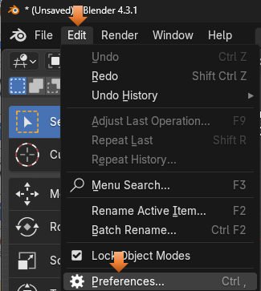

Click on Add-ons from the left panel and then click the check box for Extra Mesh Objects.

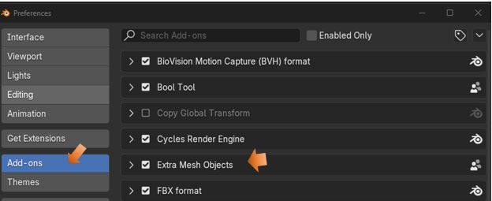

Without Extra Mesh Objects turned on all you are getting is this list of objects

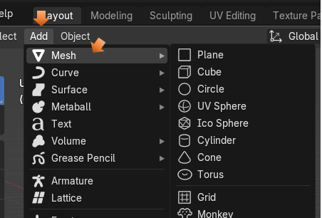

# To Find your New Extra Mesh Objects

Go to the Add Menu, and click on Mesh to access its sub menu. Here you see a whole list of other objects that can be add pipes, diamonds, single vertices, rocks.

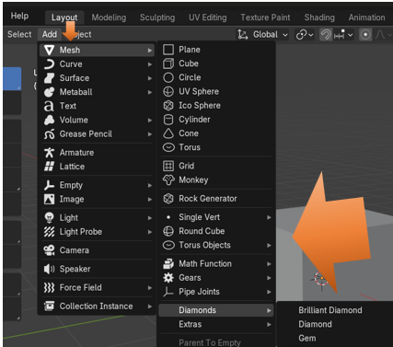

Anything with arrows after it will give you access to even more stuff. Here is what you get when you click on the arrow after Extras.

